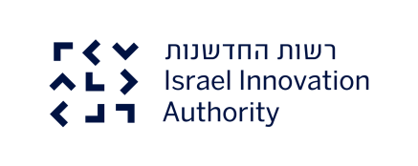
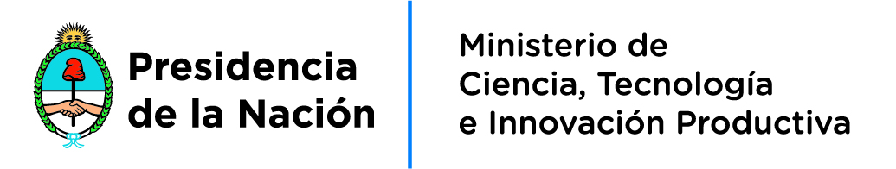

Argentina – Israel Industrial R&D Cooperation Program

2018 Call for Proposals

September 20th – December 13th 2018

The Argentina -Israel program for Industrial Research and Development is a Bilateral Framework operated by both governments to provide active support, matchmaking and funding for collaborative R&D ventures carried out between Argentinean and Israeli companies.
The Bilateral Framework Program is jointly implemented by MINCyT, The Ministry of Science Technology and Productive Innovation in Argentina and Israel Innovation Authority.
This Call aims to invite Israeli and Argentinean companies in all industry sectors to submit a joint proposal for cooperation in R&D that results in the development of new and technologically innovative products, processes or services of industrial application leading to commercialization in the domestic and/or global markets.
- Common Requirements
In order to apply for the Program Call the following requisites must be met:
- At least one R&D performing company from each country should cooperate in the joint R&D and commercialization project.
- The project may involve more than one company from each side; academic/research entities are eligible to join in as sub-contractors.
- The solution being developed should be highly innovative with clear commercial potential. The joint industrial R&D project should aim at the development of products/processes leading to commercialization in the global market.
- The project should be mutually beneficial and demonstrate contribution of the participants from both countries
- The project partners should agree in advance on the IP rights and on the commercialization strategy of the product or process.
Note: For the submission phase, only a LOI, a preliminary agreement or draft MoU is required, however the final agreement has to be submitted to the funding authorities prior to receiving grants.

Any partner whose cooperative R&D project is consistent with the aforesaid criteria may apply under the present Call for Proposals in accordance with the national Laws, Rules, Regulations and Procedures in force.
- Eligibility
In Argentina
Eligible applicants will be R&D performing Argentine registered companies operating in Argentina.

In Israel
Eligible applicants will be Israeli registered companies with R&D operations in Israel.
- Size of Investments and Matching Funds
- Funding support will be given to each partner by its own Implementing Organizations (Ministry of Science, Technology and Productive Innovation in Argentina and Israel Innovation Authority in Israel) in accordance with the National Laws, Rules, Regulations and procedures in effect.
- The total grant from the Government of Argentina under the Argentina-Israel R&D program financial support is up to 80% of the approved R&D expenditures and up to $ 2.500.000 pesos (165.000 USD) in the case of software and informatics services projects, and $ 3.500.000 (231.000 USD) for the rest of industrial areas.
- The total funding from the Government of Israel via Israel Innovation Authority, under the Argentina-Israel R&D program financial support, is up to50% of the eligible costs plus regional incentives, in accordance with national laws and regulations.
- Projects are eligible even if one of the partners choses to conduct its part on a self-funding basis. Applying bilaterally will allow the other partner in an approved project to receive the grant from its respective government.

- Submission of the project proposals
The present Call is launched on September 20th, 2018.
The call will be open until December 13th, 2018.
By the end of this call, partnering organizations will submit:
- A bilateral cooperation form demonstrating the technological contribution of the participants from both countries, signed by both partners.
- A funding application to the respective agency in their country
Note: the call does allow bilateral applications that are based on self-funding of either participant
  - Important:
- The bilateral application form must be signed by the partners from Argentina and from Israel and submitted to MINCYT and Israel Innovation Authority within the deadline of the particular call period.
- Unless approved by both sides' authorities, applications submitted after the deadline period will be returned and may be resubmitted by the interested parties in the subsequent deadline or call.
- A Letter of Intent, Preliminary Agreement, or draft MoU between the participants from both countries is required. If the proposal is approved the final agreement has to be submitted to the funding authorities.
- Documents should be submitted in both countries in English. Besides, in Argentina, a translated copy in Spanish must also be submitted -duly certified by the College of Sworn Translators-.
- Israel Innovation Authority and MINCYT will screen the forms and further evaluate the funding applications only for eligible applicants.
  - Funding application
In Israel
- The Israeli partner is required to submit the National Application Form in accordance with the Israel Innovation Authority regulations, through an online system: https://my.innovationisrael.org.il/messages
- A signed copy of the bilateral application form is required to be scanned and uploaded as well. The application in the prescribed format should be submitted to Israel Innovation Authority as well at the coordinates provided at the end of the document.
- A copy of the application and funding form must be sent by email to alan.hofman@innovationisrael.org.il
In Argentina
- Argentinean applicants are required to refer the following link for the Argentinean Application Forms and Guidelines: http://www.mincyt.gob.ar/cooperacion-internacional-empresas/empresas-199
- Evaluation and selection of the projects

MINCyT, The Ministry of Science, Technology and Productive Innovation in Argentina and Israel Innovation Authority in Israel will carry out an independent evaluation of the joint R&D application and will select the eligible project to be financially supported in accordance with their national laws and regulations. The successful projects will be jointly selected by the two implementing organizations based on the project criteria and requirements specified in the application form.

- Repayments
In Israel
According to IIA regulations
In Argentina
Financing is provided through non-refundable contributions channelled through the National Agency for Science and Technology Promotion. This funding allocation is implemented in the form of payment reimbursement made in accordance with the schedule that is part of the approved project.

For further information contact:
Israel Office
Mr. Alan Hofman
Director
Latin America Desk
Americas Operations
Israel Innovation Authority
Tel: +972-3-7157987
Email: alan.hofman@innovationisrael.org.il
Airport City 7019900, Israel 4 HaYarden St.
(P. O. Box 1099)

Argentina Office
Mr. Emiliano Zapata
Area of International Cooperation with Companies
National Directorate for Cooperation and Integration
Ministry of Science, Technology and Productive Innovation - MINCyT.
Tel: +54-11-4899-5000 int: 4096
Email : ezapata@mincyt.gov.ar

The call is open for any kind of companies; nevertheless, only SMEs companies may apply for MINCyT funding (According to Sepyme Res. 24/2001 and the amendments thereof)

